HONORS CHEMISTRY • UNIT 1
Atomic Structure
Everything in the universe is built from a few kinds of tiny particles. Learn what they are, how we found them, and how to count them.

HOW TO USE THIS PACKET
This is your notebook for the unit. Write definitions in your own words, copy the steps of each worked example, and use the blank space for sketches and questions. Boxes marked LAB CORNER are things you would do or see at a lab bench. Extra practice is at the back.

What we will learn
1.1 | Atomic structure & properties
1.2 | Atomic history: how we know what atoms look like
1.3 | Isotopes & average atomic mass
1.4 | The mole, Avogadro’s number & molar mass
★ | Extra practice & unit review

By the end of this unit I can…
• Name the three subatomic particles and state the charge, relative mass and location of each.
• Use atomic number, mass number and charge to find protons, neutrons and electrons in atoms, isotopes and ions.
• Describe the key experiment and conclusion of Dalton, Thomson and Rutherford, and how the model of the atom changed.
• Explain why atomic masses are not whole numbers and calculate average atomic mass from isotope data.
• Use the mole as a bridge between particles and grams (Avogadro’s number and molar mass).
• Interpret lab data (mass-spectrometer graphs, balance readings, crucible data) to support a claim about atoms.
TOPIC  1.1 | Atomic Structure & Properties  Protons • neutrons • electrons • ions

BIG IDEA
Every atom is made of just three particles. The number of protons decides which element it is; the neutrons add mass; the electrons decide the charge and how the atom bonds.

Key vocabulary — write each definition in your own words
Term | Definition (your words) | Example / sketch
Atom | What is it? What are its parts?
Proton | Charge? Where? What does it control?
Neutron | Charge? Where? What does it control?
Electron | Charge? Where? Size?
Nucleus | What is inside it? How big is it?
Atomic number (Z) | What does it count?
Mass number (A) | What two particles does it count?
Ion | What changes? What stays the same?

THINK OF IT LIKE… A STADIUM
If the nucleus were a marble sitting on the 50-yard line, the outer edge of the atom (the electron cloud) would be more than five football fields away. Almost all of an atom is empty space; almost all of its mass is in the marble.

THINK OF IT LIKE… A NAME TAG
The atomic number is the element’s name tag. Change a few neutrons or electrons and you still have the same element (a different isotope, or an ion). Change the number of protons and you have a completely different element.

REAL WORLD
Alchemists spent centuries trying to turn lead (82 protons) into gold (79 protons). Chemical reactions only move electrons, so they can never change the number of protons. Only nuclear reactions can (you will meet those in the Nuclear unit).

Fill in the particle table
Particle | Symbol | Charge | Relative mass (amu) | Location in the atom
Proton
Neutron
Electron

What controls what?
CUES / KEY WORDS  Identity  Mass  Charge | COMPLETE EACH LINE AND EXPLAIN WHY

1. Label the parts of the atom below (A–E).
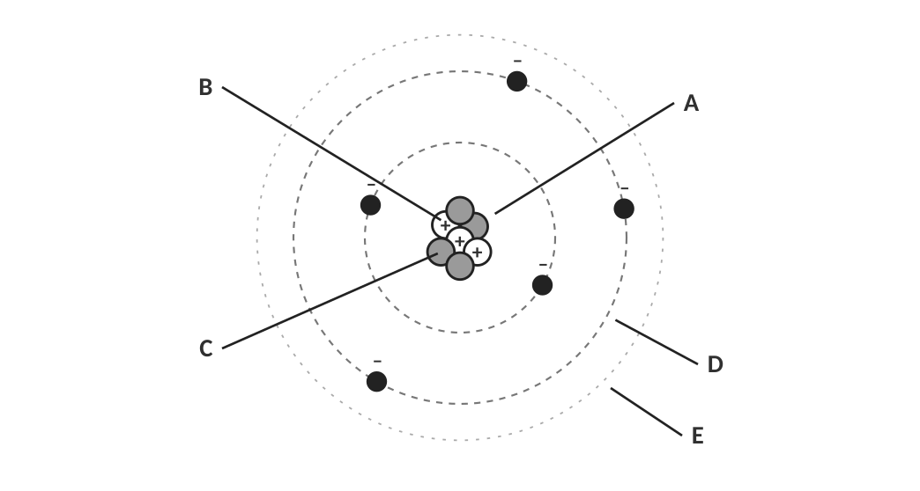
Diagram of a helium-like atom (not to scale).
A | B | C | D | E

[ IMAGE GOES HERE ]
Optional: the labeled-atom diagram from your Topic 1.1 homework

Nuclear symbols and hyphen notation
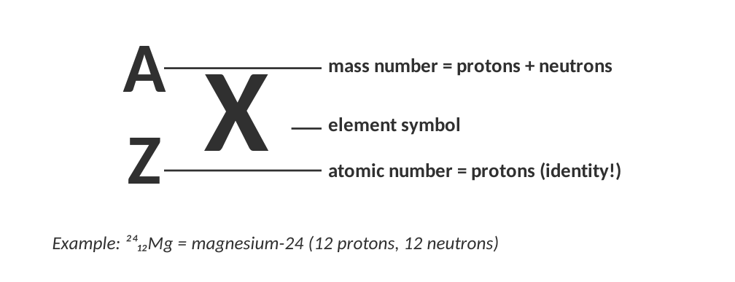
Two ways to name the same isotope.
WORKED EXAMPLE — COUNT THE PARTICLES
How many protons, neutrons and electrons are in a neutral atom of iron-56 (⁵⁶₂₆Fe)?

Work it out here:

Answer: __________________________________
THREE RULES TO MEMORIZE
• protons = atomic number (Z) (always, even in ions)
• neutrons = mass number (A) − atomic number (Z)
• electrons = protons − charge (Na⁺: 11 − (+1) = 10 e⁻; O²⁻: 8 − (−2) = 10 e⁻)

WATCH OUT!
Mass number is a whole number you count. Atomic mass (on the periodic table) is a decimal average. They are not the same thing. You’ll see why in Topic 1.3.

Practice: fill in every blank
Isotope name | Nuclear symbol | Atomic # | Mass # | Protons | Electrons | Neutrons
carbon-14
 |  | 29 | 64
 |  |  |  | 92 |  | 146
 |  |  |  |  | 18 | 22
 |  |  | 108 | 47
 |  | 8 |  |  |  | 10
 | ¹⁹₉F

Ions: when the number of electrons changes
CUES / KEY WORDS  Ion  Cation  Anion | HOW DOES AN ATOM BECOME AN ION? WHAT ARE THE TWO TYPES?

THINK OF IT LIKE… A BANK ACCOUNT
Protons are the account’s fixed deposits; electrons are the cash you can add or take away. Losing electrons (cash) leaves the atom more positive; gaining electrons leaves it more negative. A tip to remember: cations are +itive (the t looks like a plus sign); anions have a negative charge.

Ion | Cation or anion? | Protons | Electrons | Gained or lost how many e⁻?
Al³⁺
O²⁻
K⁺
N³⁻
Ca²⁺
Br⁻

2. An ion has 26 protons and 23 electrons. What is its charge, and is it a cation or an anion? Name the ion (hint: look at the periodic table).

3. Explain why the mass of a Na⁺ ion is practically identical to the mass of a neutral Na atom, even though they are different particles.

4. A student says: "If I add a proton to a neutral oxygen atom I get an O⁻ ion." Correct the statement.

LAB CORNER • Reading an element tile

Chemists read the periodic table like a label on a food package. Use the tile below for aluminum.
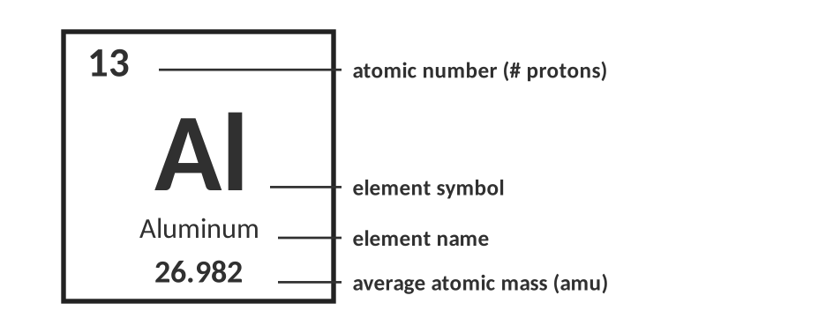
A typical periodic table tile.
Question | Your answer
Which number is the atomic number? How many protons does an Al atom have?
Which number is the atomic mass? Why isn’t it a whole number?
How many electrons are in an Al³⁺ ion?
Most aluminum atoms have 14 neutrons. What is the mass number of that isotope?

Check for understanding
5. Which particle(s) contribute significantly to the mass of an atom?
A) electrons only
B) protons and neutrons
C) protons and electrons
D) neutrons and electrons

6. Two atoms have the same number of protons but different numbers of neutrons. They are…
A) different elements
B) isotopes of the same element
C) ions of the same element
D) impossible

TOPIC  1.2 | Atomic History  Dalton • Thomson • Rutherford • and the evidence behind each model

BIG IDEA
A model of the atom is only as good as the evidence behind it. Every time scientists did a new experiment and got a surprising result, the model had to change.

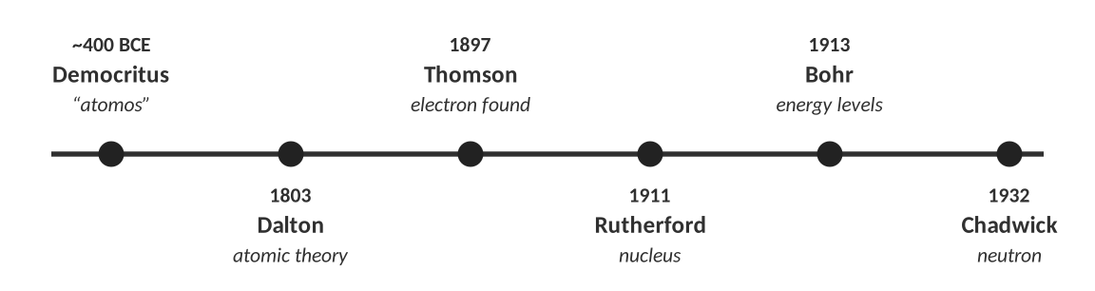
How our picture of the atom developed.
THINK OF IT LIKE… A MYSTERY BOX
Imagine a sealed shoe box with something hidden inside. You can’t open it, but you can roll marbles through it and see where they come out. If every marble goes straight through, the box is empty. If some bounce back, something solid is in there. Rutherford did exactly this with atoms, using alpha particles for marbles.

Dalton’s atomic theory (about 1803)
CUES / KEY WORDS  Atoms  Elements  Compounds  Reactions | WRITE EACH OF DALTON’S IDEAS IN YOUR OWN WORDS

Dalton’s idea | Does modern theory agree? Explain.
Atoms are indivisible (the smallest form of matter).
All atoms of an element are identical.
Atoms are never created or destroyed in a chemical reaction.

LAB CORNER • The burning magnesium ribbon

A student burns magnesium ribbon in a crucible with a lid, then re-weighs the white powder. She repeats the experiment three times.
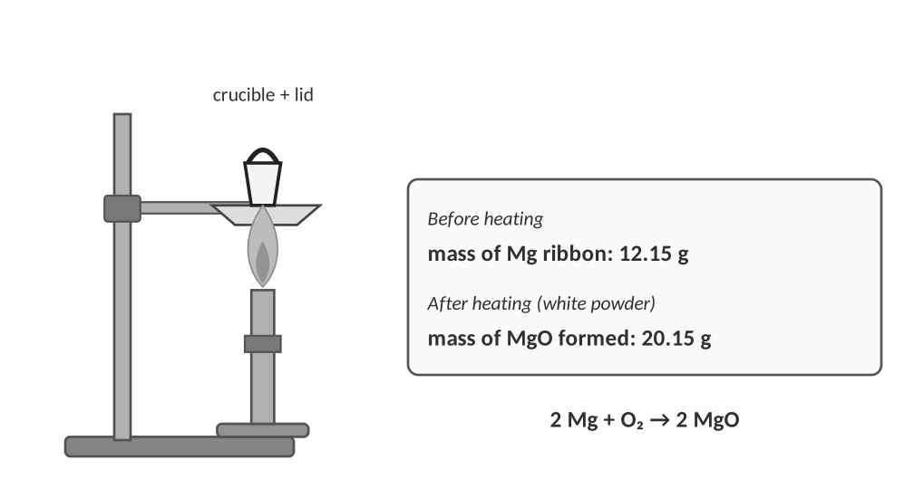
1. The solid’s mass increased. Use Dalton’s theory to explain where the extra mass came from, and calculate it for the first trial.
a. How many grams of oxygen combined with the 12.15 g of magnesium?

b. Explain the answer using one of Dalton’s ideas.

Trial | Mg used (g) | MgO formed (g) | O gained (g) | Mass Mg ÷ mass O
1 | 12.15 | 20.15
2 | 6.08 | 10.08
3 | 9.12 | 15.12

2. What pattern do you notice in the last column? What does it suggest about how magnesium and oxygen combine?

3. Suppose white smoke escaped from the crucible when the lid was lifted and the student’s final mass was only 18.9 g. Does this break the law of conservation of mass? Explain.

Thomson: the electron (1897)
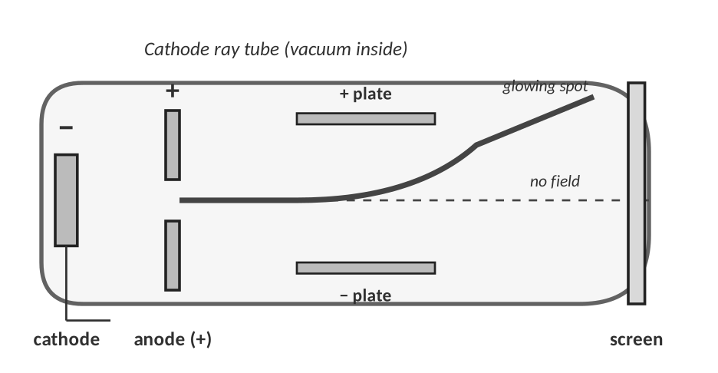
Cathode ray tube. Rays travel from the cathode (−) to the anode (+).
Observation | What Thomson concluded
A glowing ray travels from the negative electrode (cathode) to the positive end.
When a positively charged plate is placed near the ray, the ray bends toward it.
The ray’s behaviour did not change when a different metal was used for the cathode.
The particles were about 1/1800 as massive as a hydrogen atom.

4. What evidence did Thomson use to decide the particle had a charge, and what was the sign of the charge?

5. Thomson’s atom was electrically neutral but contained negative electrons. Describe his model, name it, and sketch it in the box.

Sketch your own plum-pudding model here:

LAB CORNER • Charged tape

A teacher sticks two strips of tape to a desk, peels them off, and holds them near each other. Strips of the same type repel each other. Strips of different types attract.
Pair | What happens | What does it show?
Top strip + top strip | repel
Bottom strip + bottom strip | repel
Top strip + bottom strip | attract

KEY RULE
Like charges repel. Opposite charges attract. You will use this rule to explain Rutherford’s experiment, bonding, ionization energy and nearly everything else in chemistry.

Rutherford: the nucleus (1911)
Rutherford’s team aimed a beam of alpha (α) particles (positively charged helium nuclei) from a radioactive source at an extremely thin sheet of gold foil, and used a screen to detect where the particles ended up.
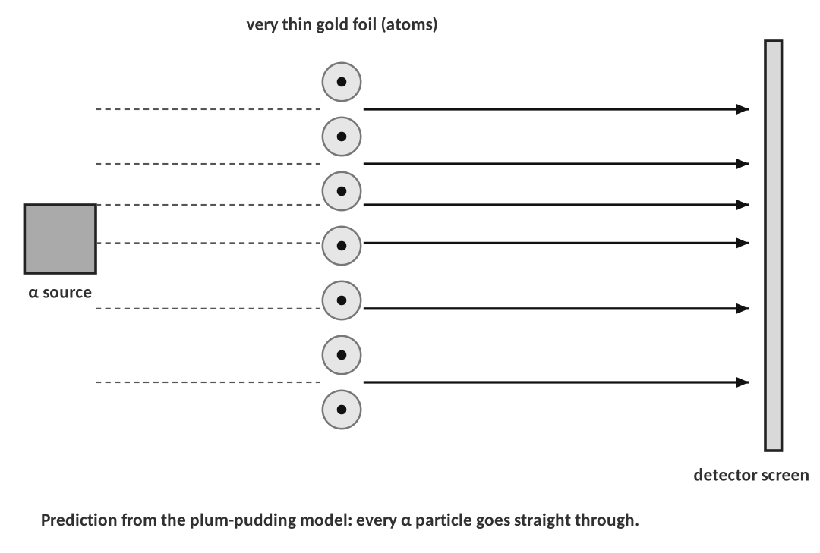
6. The plum-pudding model predicted every alpha particle would pass straight through. Why? (Think about the charge of the particles and how it is spread out in Thomson’s atom.)

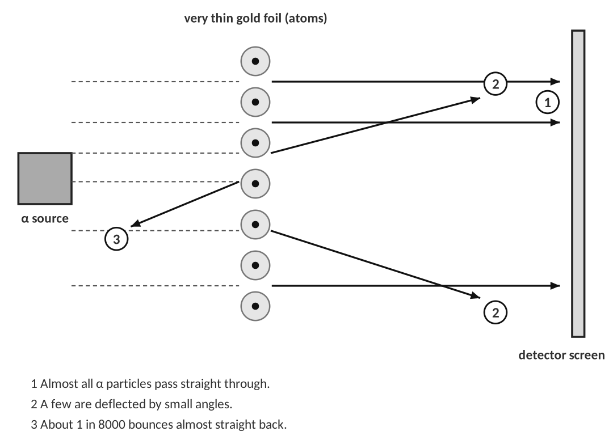
7. Describe the results of the experiment. Be specific about what happened to the alpha particles.

Observation | Conclusion about the atom
Most α particles passed straight through.
A few α particles were deflected.
1 in 8000 bounced almost straight back.

THINK OF IT LIKE… SHOOTING AT A HAYSTACK
You fire 8000 bullets at a haystack. Almost all of them pass through, but about one bounces straight back. You would conclude that something small, hard and heavy is hidden in the hay. Rutherford later said it was as surprising as firing a huge artillery shell at tissue paper and having it come back at you.

8. A lab fires 2.4 × 10⁵ alpha particles at a gold foil. About how many would you expect to bounce back?
Work:

Answer: __________________________________
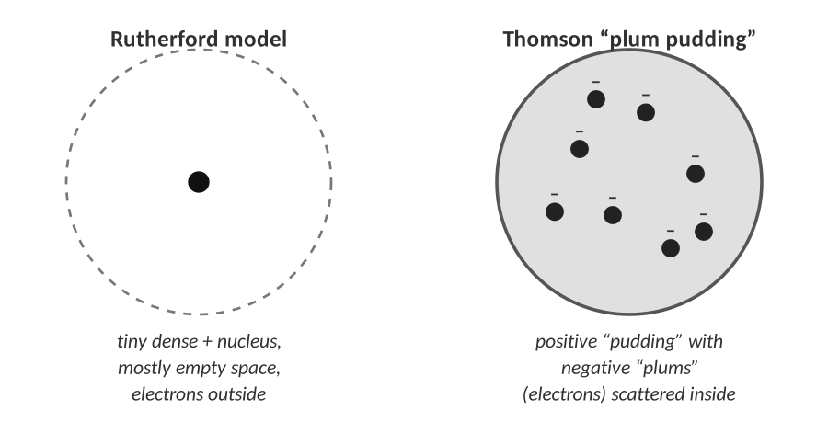
Thomson (left) and Rutherford (right)

9. Describe Rutherford’s new model of the atom and draw it. What did it fail to explain?

[ IMAGE GOES HERE ]
Optional: the Rutherford experiment diagram from your Topic 1.2 homework or an AP exam figure

After Rutherford
Scientist | Year | Contribution
Bohr | 1913
Chadwick | 1932
Schrödinger and others | 1920s

Check for understanding — match the evidence to the scientist
Evidence | Scientist | Model it supports
Cathode ray bends toward a positive plate
Some α particles bounce straight back from gold foil
Mass is the same before and after burning (closed system)
Atoms of one element with different masses

TOPIC  1.3 | Isotopes & Average Atomic Mass  Same protons, different neutrons • weighted averages • mass spectra

BIG IDEA
Atoms of the same element can have different numbers of neutrons (isotopes). The atomic mass on the periodic table is a weighted average of all the isotopes, which is why it is almost never a whole number.

Key vocabulary — write each definition in your own words
Term | Definition (your words) | Example / sketch
Isotope | What is the same? What is different?
Atomic mass unit (amu) | What is it used to measure?
Percent abundance | Of what, in what?
Average atomic mass | How is it different from mass number?
Mass spectrometer | What does it measure?

ISOTOPE NAMES
Isotopes are named with the element and the mass number: carbon-14 or C-14, also written ¹⁴₆C.
Hydrogen is the only element whose isotopes have their own names: protium (H-1, 0 n), deuterium (H-2, 1 n) and tritium (H-3, 2 n).

Isotope | Protons | Neutrons | Electrons (neutral) | Mass number
Mg-24
Mg-25
Mg-26

1. Which of the following pairs are isotopes of the same element? ¹²₆C and ¹⁴₆C; ¹⁴₆C and ¹⁴₇N; ³⁵₁₇Cl and ³⁷₁₇Cl

Why isn’t the atomic mass a whole number?
THINK OF IT LIKE… YOUR GRADE IN A CLASS
Tests are worth 70% of your grade and homework is worth 30%. You average 90 on tests and 60 on homework. Your grade is not (90 + 60) ÷ 2 = 75, because the tests count more: 0.70 × 90 + 0.30 × 60 = 81. An element’s atomic mass is the same kind of average: each isotope “counts” in proportion to how common it is.

WORKED EXAMPLE — WEIGHTED AVERAGE
Boron has two isotopes: B-10 (10.013 amu → use 10 amu) is 19.9% abundant and B-11 (use 11 amu) is 80.1% abundant. Calculate the average atomic mass.

Work it out here:

Answer: __________________________________
THE RECIPE
Average atomic mass = (mass₁ × abundance₁) + (mass₂ × abundance₂) + … (write abundances as decimals; they add to 1.00)

WATCH OUT!
Never just add the masses and divide by the number of isotopes. A simple average treats a rare isotope as if it were as common as a common one.

LAB CORNER • Penny isotopes

Pennies minted before 1982 are almost pure copper; pennies minted after are mostly zinc with a thin copper coating. They look alike but have different masses, so they behave like two isotopes of “the penny.”
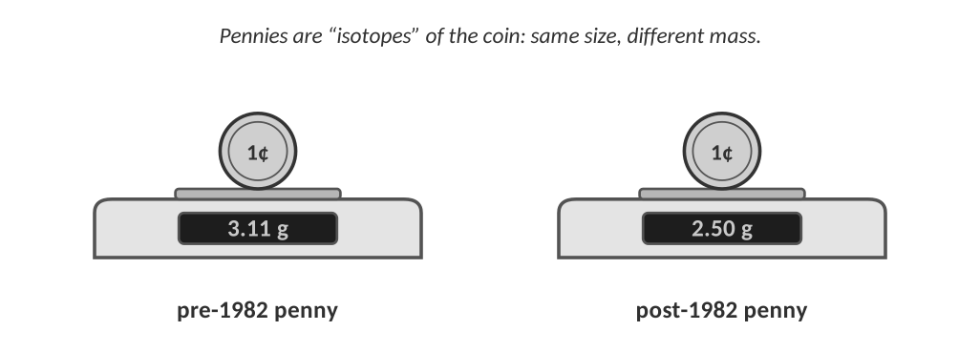
A student weighs a bag of 50 pennies by sorting them and counting. She finds 31 pre-1982 pennies and 19 post-1982 pennies.
Type | Number | Abundance (decimal) | Mass of one (g) | Abundance × mass (g)
Pre-1982 | 31 |  | 3.11
Post-1982 | 19 |  | 2.50

2. Calculate the average mass of a penny in this bag.
Work:

Average mass: __________________________________
3. Is any single penny in the bag actually 2.88 g? What does this tell you about the atomic mass of an element like chlorine?

4. Is the average closer to the mass of the pre-1982 penny or the post-1982 penny? Why?

LAB CORNER • Reading a mass spectrum

A mass spectrometer ionizes atoms, speeds them up and bends their path with a magnet. Lighter ions bend more than heavier ones, so the instrument sorts the atoms by mass and counts how many of each arrive.
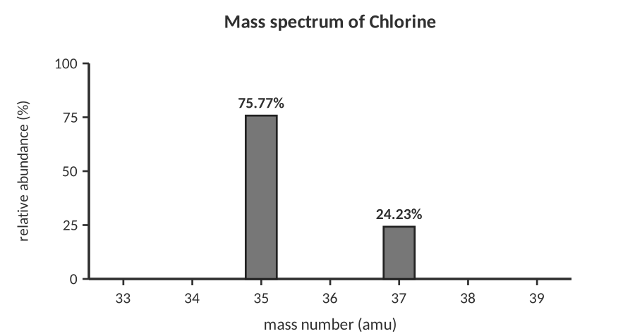
Mass spectrum of a sample of chlorine.
Question | Your answer
How many isotopes of chlorine are in the sample?
What are their masses and abundances?
Without calculating, predict whether the average will be closer to 35 or 37. Why?

5. Calculate the average atomic mass of chlorine from the graph (use the mass numbers as the masses).
Work:

Average atomic mass: __________________________________
6. In a sample of 1000 chlorine atoms, about how many are Cl-35 and how many are Cl-37?

[ IMAGE GOES HERE ]
Optional: the mass-spectrometer or carbon-isotope data table from your Topic 1.3 homework

Practice
7. Lithium has two isotopes: Li-6 (7.59%) and Li-7 (92.41%). Calculate the average atomic mass of lithium.
Work:

Answer (units & sig figs): __________________________________
8. Magnesium has three isotopes: Mg-24 (78.99%), Mg-25 (10.00%) and Mg-26 (11.01%). Calculate its average atomic mass.
Work:

Answer (units & sig figs): __________________________________
9. An unknown element has two isotopes: one of mass 107 amu (51.84%) and one of mass 109 amu (48.16%). Calculate the average atomic mass and identify the element using your periodic table.
Work:

Answer (units & sig figs): __________________________________
10. Boron’s average atomic mass is 10.8 amu. Its two isotopes have masses of 10 and 11 amu. Without doing a full calculation, which isotope is more abundant and why? Then use algebra to find the percent abundance of the heavier isotope.
Work:

Abundance of heavier isotope: __________________________________
11. Carbon’s atomic mass is 12.01 amu, very close to 12. What does this tell you about the abundance of C-12 compared with C-13 and C-14?

REAL WORLD
Carbon-14 is radioactive. Living things take it in all the time; when they die the C-14 slowly decays, so measuring how much is left tells scientists how old a bone or a piece of wood is (radiocarbon dating). Iodine-131 is used in medicine to treat thyroid disease.

Check for understanding
12. Chlorine’s atomic mass is 35.45 amu. Which statement is true?
A) Every chlorine atom has a mass of 35.45 amu.
B) Chlorine is a mixture of isotopes, mostly with masses near 35 and 37 amu.
C) Chlorine atoms contain 35.45 neutrons.
D) The decimal comes from the mass of the electrons.

13. Two isotopes of the same element always have the same…
A) mass number
B) number of neutrons
C) number of protons
D) atomic mass

TOPIC  1.4 | The Mole, Avogadro’s Number & Molar Mass  Counting atoms by weighing them

BIG IDEA
Atoms are far too small to count one by one, so chemists count them in huge groups called moles. 1 mole = 6.022 × 10²³ particles, and the mass of 1 mole of an element in grams equals its atomic mass.

Key vocabulary — write each definition in your own words
Term | Definition (your words) | Example / sketch
Mole (mol) | Compare it to a dozen.
Avogadro’s number | Write it in scientific notation.
Molar mass (g/mol) | How do you find it for an element?
Conversion factor | What makes it equal to 1?

THINK OF IT LIKE… A DOZEN, A REAM, A GROSS
We already count by groups: a dozen eggs is 12, a ream of paper is 500 sheets. A dozen eggs and a dozen bowling balls contain the same *number* of objects but have very different *masses*. A mole is just a bigger group; a mole of carbon and a mole of lead both contain 6.022 × 10²³ atoms but have very different masses (12.01 g and 207.2 g).

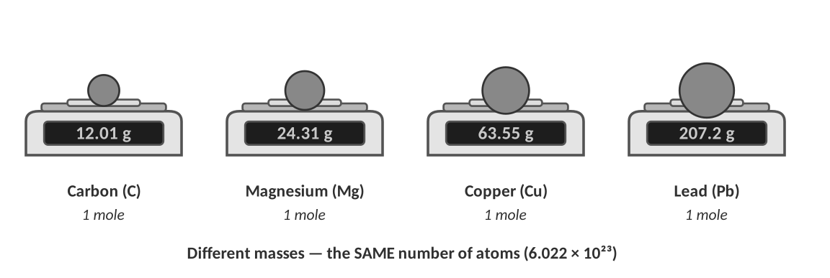
REAL WORLD
How big is a mole? If you could count one atom every second, it would take about 1.9 × 10¹⁶ years, roughly 1.4 million times the age of the universe, to count a single mole.
A mole of liquid water (18.02 g) is only about 18 mL, a little more than a tablespoon. That small amount holds 6.022 × 10²³ water molecules.

The mole is the bridge
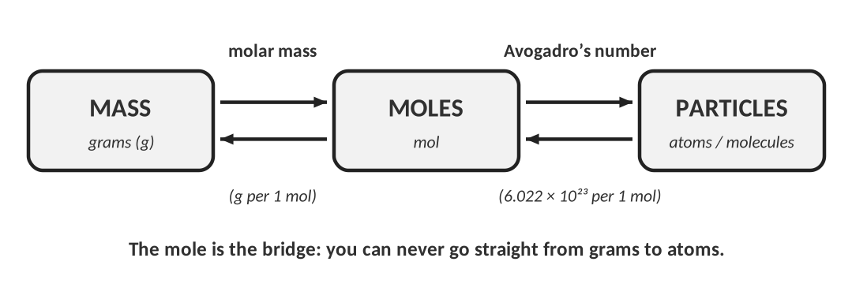
CUES / KEY WORDS  Mole → particles  Mole → grams | WRITE THE TWO CONVERSION FACTORS AND WHEN TO USE EACH

Molar mass from the periodic table
Element | Molar mass (g/mol) | Element | Molar mass (g/mol)
Lithium |  | Copper
Nitrogen |  | Silver
Silicon |  | Gold
Calcium |  | Lead

Worked examples
WORKED EXAMPLE — MOLES → ATOMS
Convert 2.50 mol of carbon to atoms of carbon.

Work it out here:

Answer: __________________________________
WORKED EXAMPLE — ATOMS → MOLES
Convert 5.15 × 10²³ atoms of sulfur to moles of sulfur.

Work it out here:

Answer: __________________________________
SET-UP CHECK
Write the unit you have, then a fraction with that unit on the bottom so it cancels. The unit you want goes on top. If your units don’t cancel, flip the fraction.

LAB CORNER • A balance reading and the mole bridge

A student places a coil of copper wire on a balance. The reading is shown below.
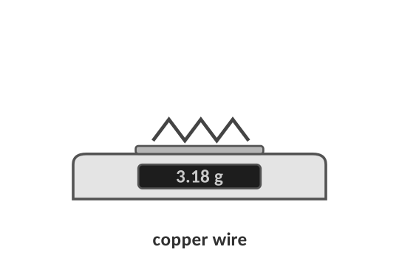
1. How many moles of copper are in the coil? How many copper atoms?
a. Convert the mass to moles (molar mass of Cu = 63.55 g/mol).
Work:

Answer (units & sig figs): __________________________________
b. Convert the moles to atoms.
Work:

Answer (units & sig figs): __________________________________
2. A sample contains 2.50 × 10²² atoms of zinc. What is its mass in grams? (Zn = 65.38 g/mol)
Work:

Answer (units & sig figs): __________________________________
WORKED EXAMPLE — ISOTOPES IN A MOLE
One mole of the unknown element from Topic 1.3 (isotopes 107 amu: 51.84% and 109 amu: 48.16%) contains 6.022 × 10²³ atoms. How many atoms of each isotope are in the sample?

Work it out here:

Answer: __________________________________
Counting by weighing (a lab technique)
You can’t count atoms, but you can count nuts and bolts by weighing them. A hardware store does this all the time.
3. A student weighs 25 identical steel nuts and finds the mass is 31.4 g. She then weighs a big bag of the same nuts and finds 502 g. About how many nuts are in the bag?
Work:

Number of nuts: __________________________________
4. How is this the same as using molar mass to count atoms? What plays the role of “25 nuts = 31.4 g”?

Molar mass of a compound (preview)
For a compound, add up the molar masses of every atom in the formula.
WORKED EXAMPLE — WATER
Find the molar mass of H₂O.

Work it out here:

Answer: __________________________________
Compound | Work | Molar mass (g/mol)
CO₂
NaCl
Ca(OH)₂

Check for understanding
5. Which sample contains the most atoms?
A) 10.0 g of carbon
B) 10.0 g of magnesium
C) 10.0 g of lead
D) They all contain the same number.

6. Explain your answer to the question above without doing any calculations.

WATCH OUT!
One mole of different elements has the same number of atoms but different masses. One mole of the same element always has the same mass.

PRACTICE
Extra Practice — Unit 1
Work these on your own or with a partner. Show all work.

A. Particles, isotopes and ions
Isotope name | Nuclear symbol | Atomic # | Mass # | Protons | Electrons | Neutrons
 |  | 11 | 23
sulfur-34
 |  |  |  | 50 |  | 70
 | ²²₁₀Ne

Particle | Protons | Neutrons | Electrons | Symbol with charge (e.g. Ca²⁺)
Atom with Z = 12, A = 24 that lost 2 e⁻
Atom with Z = 16, A = 32 that gained 2 e⁻
Atom with 20 p⁺, 20 n⁰ and 18 e⁻
Atom with 35 p⁺, 44 n⁰ and 36 e⁻

1. Atoms of fluorine always have 9 protons. Atoms of neon always have 10. Explain how a scientist could be sure that a sample labeled “fluorine” really is fluorine.

B. Atomic history
2. Match each scientist with an observation and a conclusion. Write the scientist’s name in the first column.
Scientist | Observation | Conclusion
 | A ray in a glass tube bends toward a positive plate.
 | 1 in 8000 alpha particles bounces back from gold foil.
 | Mass doesn't change in a sealed reaction vessel.

3. Imagine you repeated Rutherford’s experiment using a thin sheet of aluminum (13 protons) instead of gold (79 protons). Predict whether more, fewer or the same fraction of alpha particles would bounce straight back. Explain using what you know about the nucleus.

4. A teacher says: "Thomson’s model was wrong, so his experiment was a waste of time." Argue against this statement.

C. Isotopes and average atomic mass
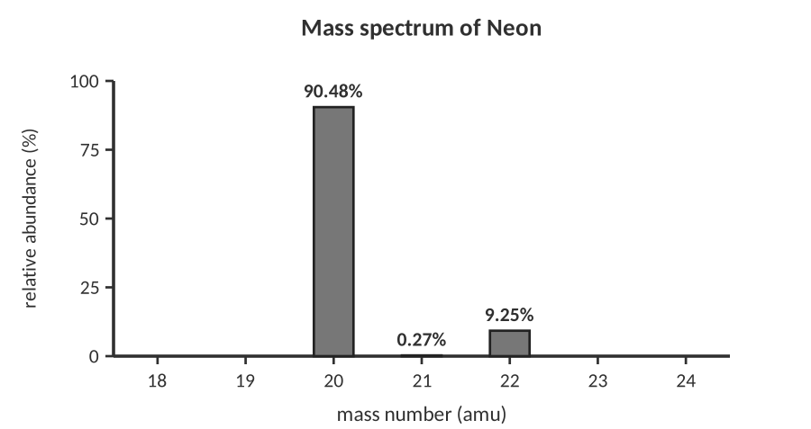
Mass spectrum of a sample of neon.
5. Use the graph to calculate the average atomic mass of neon (use whole-number isotope masses).
Work:

Answer (units & sig figs): __________________________________
6. Gallium has two natural isotopes, Ga-69 (60.11%) and Ga-71 (39.89%). Calculate the average atomic mass.
Work:

Answer (units & sig figs): __________________________________
7. Silicon has three isotopes: Si-28 (92.23%), Si-29 (4.68%) and Si-30 (3.09%). Calculate the average atomic mass.
Work:

Answer (units & sig figs): __________________________________
8. A new element “Chemium” (Cm) has two isotopes: Cm-50 (mass 50 amu) and Cm-52 (mass 52 amu). Its average atomic mass is 50.6 amu. What is the percent abundance of each isotope?
Work:

Abundances: __________________________________
9. Two students are asked for the atomic mass of sodium, which is 22.99 amu. Student A says a single sodium atom has a mass of 22.99 amu. Student B says that is the average of all natural sodium atoms and that nearly all of them are Na-23. Who is more correct? Use the idea of isotopes.

D. The mole
10. How many atoms are in 0.250 mol of aluminum?
Work:

Answer (units & sig figs): __________________________________
11. How many moles are in 3.01 × 10²⁴ atoms of calcium?
Work:

Answer (units & sig figs): __________________________________
12. What is the mass of 2.40 mol of magnesium? (24.31 g/mol)
Work:

Answer (units & sig figs): __________________________________
13. How many moles of iron are in 100.0 g of iron? (55.85 g/mol)
Work:

Answer (units & sig figs): __________________________________
14. How many atoms are in 10.0 g of helium? (4.003 g/mol)
Work:

Answer (units & sig figs): __________________________________
15. What is the mass of one atom of gold, in grams? (196.97 g/mol)
Work:

Answer (units & sig figs): __________________________________
16. Which has more atoms: 1.00 g of lithium or 1.00 g of lead? Explain without calculating.

17. A student claims: "A mole of helium has a mass of 6.022 × 10²³ g." What mistake did the student make?

E. Lab data analysis
LAB CORNER • Finding the average mass of an “element” in a bag of beads

A teacher hands out a bag containing round beads of three different masses. Students sort and weigh the beads.
Bead type | Number of beads | Mass of one bead (g)
Red | 42 | 0.85
Blue | 35 | 0.90
Green | 23 | 0.95

18. Calculate (a) the percent abundance of each bead type, and (b) the average mass of a bead.
Work:

Average bead mass: __________________________________
19. The students then weigh a large pile of the same beads and get 1.20 kg. Use the average mass to estimate the number of beads. How is this like using molar mass?

[ IMAGE GOES HERE ]
Optional: AP-style figure of a mass spectrometer, or a photo of a balance reading

TOPIC  ★ | Unit 1 Review  Put it in your own words before the test

1. Explain in two or three sentences what an isotope is and how it is different from an ion.

2. Why did Rutherford’s experiment require a new model of the atom? What did the plum-pudding model predict, and what actually happened?

3. Describe, step by step, how you would find the number of atoms in 25.0 g of an element. Include the two conversion factors.

4. Complete the concept map: write each word in the correct circle and add a short phrase to each arrow. words: atom, nucleus, proton, neutron, electron, isotope, ion, mole
Concept map:

